

Use Case Specification: CSR eCL Quality Report Feed
For

eCoaching Log

Change History Log

Date | Version | Description | Author
07/11/2016 | 1.0 | Initial Document | Doug Stearns
07/26/2016 | 1.1 | TFS3179 – eCL Kudos data feed  Modified the following  3.8, 3.9, 4.2.1 | Doug Stearns

Table of Contents

1. Brief Description 6
2. Participating Actors 6
2.1 Primary 6
2.2 Secondary 6
3. Basic Flow of Events 7
3.1 System process executes at the scheduled time. 7
3.2 Input file accessed from appropriate folder. 7
3.3 eCoaching Log information is read from the input file. 7
3.4 Assign the coaching log Program from the input file Program. 7
3.5 Assign the value of the coaching log source id depending on the report code id: 7
3.6 Assign ‘Pending Acknowledgement’ as the value of the coaching log status. 7
3.7 Assign the coaching log Site ID from the input file Site ID. 7
3.8 Assign the coaching log Employee LAN ID from the input CSR (LAN ID). 7
3.9 Assign the coaching log Employee ID from the Employee record Employee ID when a match is found with the input CSR (LAN ID). 7
3.10 Assign 999999 as the value of the coaching log Submitter ID. 7
3.11 Assign the coaching log Eventl Date from the input Event Date. 7
3.12 Assign 0 as the value for whether an Avoke ID is associated with the input record. 7
3.13 Assign 0 as the value for whether a NGD Activity ID is associated with the input record. 7
3.14 Assign 0 as the value for whether an UCID is associated with the input record. 7
3.15 Assign 0 as the value for whether a Verint ID is associated with the input record. 7
3.16 Assign the coaching log Description from the input text description field from input file. 7
3.17 Assign the coaching log Submitted Date from the input file. 8
3.18 Assign the coaching log Start Date from the input Event Date. 8
3.19 Assign 0 as the value of whether this coaching log is Acknowledged. 8
3.20 Assign 0 as the value of whether this is a Customer Service Escalation. 8
3.21 Assign 1 as the value of the coaching log Module ID. 8
3.22 Assign the coaching log Report Code from the input strReportCode. 8
3.23 Assign 1 as the value of the coaching log Module ID. 8
3.24 Assign the value of the coaching log Reason, coaching log sub-reason and the value for the coaching log depending on the report code id: 8
3.25 Assign value of employee’s supervisor. 8
3.26 Assign value of employee’s manager. 8
3.27 Submit the CSR Quality Report eCoaching Log 8
4. Alternative Flows 9
4.1 Assign the coaching log Program. [Step 3.4] 9
4.2 Employee Not Found. [Step 3.8] 9
4.3 Duplicate eCoaching Logs. [Step 3.21, 3.22] 9
5. Preconditions 9
5.1 Quality Report eCoaching Log input file exists and is available. 9
5.2 eCoaching Log database available. 9
5.3 eCoaching Log database populated with correct and current hierarchy information for Employee, Supervisors, Managers. 9
6. Postconditions 9
6.1 eCoaching Log submitted. 9
7. Assumptions and Dependencies 9
7.1 Input file is processed every day. 9
8. Business Rules 9
8.1 none 9
9. Technical Requirements 9
9.1 none 9
10. Activity Diagrams 10

Table of Figures
Figure 1 – CSR Quality Report eCL Submission 10

Brief Description
Allow eCoaching Logs from Quality Reporting to be submitted through Quality Report data feed.

Participating Actors

Primary

System process

Customer Service Representatives

Secondary

Supervisors

Basic Flow of Events

System process executes at the scheduled time.

Input file accessed from appropriate folder.

eCoaching Log information is read from the input file.

Assign the coaching log Program from the input file Program.

Assign the value of the coaching log source id depending on the report code id:

Report Code | Report | Source
KUD | Kudos | Internal CCO Reporting
HFC | High Five CSAT | Internal CCO Reporting

Assign ‘Pending Acknowledgement’ as the value of the coaching log status.

Assign the coaching log Site ID from the input file Site ID.

Assign the coaching log Employee LAN ID from the input CSR (LAN ID) or coaching log Employee ID from the input CSR (Employee ID).

Assign the coaching log Employee ID from the Employee record Employee ID when a match is found with the input CSR (LAN ID) or Employee LAN ID from the Employee record Employee ID when a match is found with the input CSR (Employee ID).

Assign 999999 as the value of the coaching log Submitter ID.

Assign the coaching log Event Date from the input Event Date.

Assign 0 as the value for whether an Avoke ID is associated with the input record.

Assign 0 as the value for whether a NGD Activity ID is associated with the input record.

Assign 0 as the value for whether an UCID is associated with the input record.

Assign 0 as the value for whether a Verint ID is associated with the input record.

Assign the coaching log Description from the input text description field from input file.

The following characters from the input record will be replaced with the corresponding string of characters:
& | &amp;
< | &lt;
> | &gt;
` | &#39;
" | &quot;
‘ | &lsquo;
’ | &rsquo;
’ | &prime;
? | &Prime;
“ | &ldquo;
” | &rdquo;
- | &ndash;

Assign the coaching log Submitted Date from the input file.

Assign the coaching log Start Date from the input Start Date.

Assign 0 as the value of whether this coaching log is Acknowledged.

Assign 0 as the value of whether this is a Customer Service Escalation.

Assign 1 as the value of the coaching log Module ID.

Assign the coaching log Report ID and Report Code from the input Report ID and Report Code.

Assign the value of the coaching log Reason, coaching log sub-reason and the value for the coaching log depending on the report code id:

Report Code | Coaching Reason | Opportunity/Reinforcement | Coaching Sub-reason
KUD | Recognition | Reinforcement | Other: Specify reason under coaching details.
HFC | Quality | Reinforcement | CSAT

Assign value of employee’s supervisor.

Assign value of employee’s manager.

Submit the CSR Quality Report eCoaching Log

Alternative Flows

Assign the coaching log Program. [Step 3.4]

When input Program Name is not present, then assign the coaching log Program from the employee record.

Continue with step 3.5 above.

Employee Not Found. [Step 3.8]

When input Employee LAN ID or Employee ID match is not found in the Employee records reject the input record.

Continue with Step 3.9 above.

Duplicate eCoaching Logs. [Step 3.22]

When input Report ID and Report Code match an existing coaching log’s Report ID and Report Code reject the input record.

Continue with Step 3.23 above.

Preconditions

Quality Report eCoaching Log input file exists and is available.

eCoaching Log database available.

eCoaching Log database populated with correct and current hierarchy information for Employee, Supervisors, Managers.

Postconditions

eCoaching Log submitted.

Assumptions and Dependencies

Input file is processed every day.

Business Rules

none

Technical Requirements

none

Activity Diagrams
Below is the activity diagram for the use case that provides a visual depiction of the flow of events.

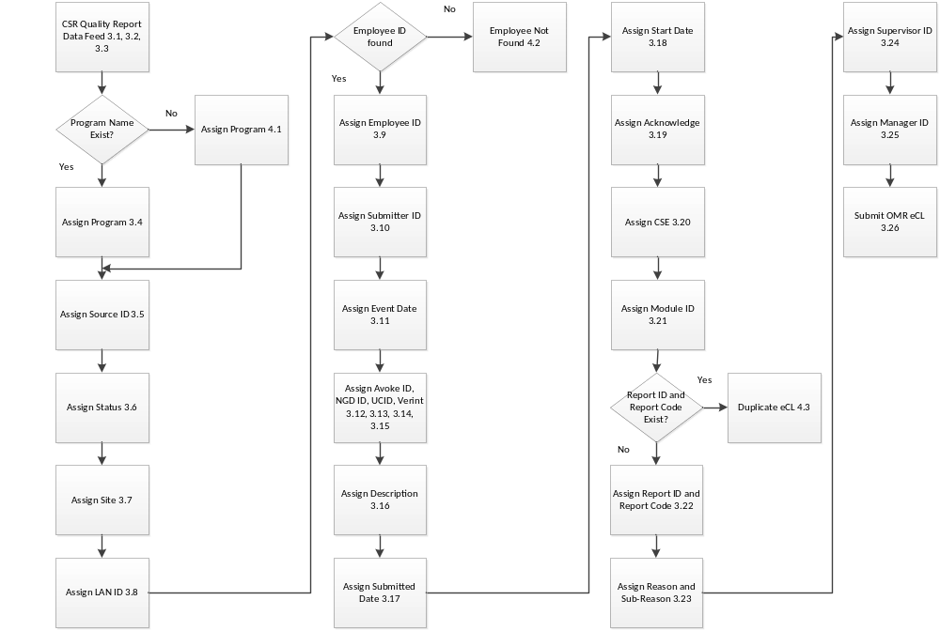

Figure 1 – CSR Quality Report eCL Submission

